1)Define P-N junction diode. Explain its operation in forward biased condition and reverse biased condition.(2)

Ans:- A PN-junction diode is formed when a p-type semiconductor is fused to an n-type semiconductor creating a potential barrier voltage across the diode junction. passing current through itself in one direction only.

Reverse Bias – The voltage potential is connected negative, (-ve) to the P-type material and positive, (+ve) to the N-type material across the diode which has the effect of Increasing the PN junction diode’s width.

Forward Bias – The voltage potential is connected positive, (+ve) to the P-type material and negative, (-ve) to the N-type material across the diode which has the effect of Decreasing the PN junction diodes width.

2) Define threshold voltage and peak inverse voltage.(2)

Ans:- A threshold voltage refers to the voltage at which certain result occurs. Usually, it is the minimum voltage required for conduction to occur but not exclusively used to mean that.

Most of the time, it means when the voltage is at or above that value, the insulation barrier will have an electrical breakdown.

Peak inverse voltage:- The maximum value of the reverse voltage that a PN junction or diode can withstand without damaging itself is known as its Peak Inverse Voltage.

3) Define half wave rectifier. What is the need of rectification? .(2)

Ans:- A halfwave rectifier is defined as a type of rectifier that allows only one-half cycle of an AC voltage waveform to pass while blocking the other half cycle.

In a regulated power supply, rectification is needed to convert AC voltage into a DC voltage

Direct current is necessary for televisions, computers, battery chargers, mobile phone chargers etc.

4) Define Rectifier. Explain the working principle of Bridge full wave rectifier with neat diagram. Also write its ripple factor and efficiency formula.(5)

Ans:- A rectifier is an electrical device that converts alternating current (AC), which periodically reverses direction, to direct current (DC), which flows in only one direction. The reverse operation is performed by the inverter.The process is known as rectification, since it "straightens" the direction of current.

Working

When an AC signal is applied across the bridge rectifier, during the positive half cycle, terminal A becomes positive while terminal B becomes negative. This results in diodes D1 and D3 to become forward biased while D2 and D4 become reverse biased.

The current flow during the positive half-cycle is shown in the figure below:

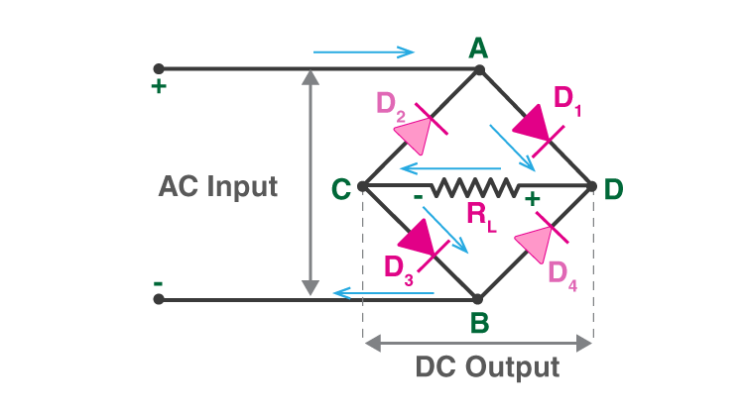

During the negative half-cycle, terminal B becomes positive while the terminal A becomes negative. This causes diodes D2 and D4 to become forward biased and diode D1 and D3 to be reverse biased.

The current flow during the negative half cycle is shown in the figure below:

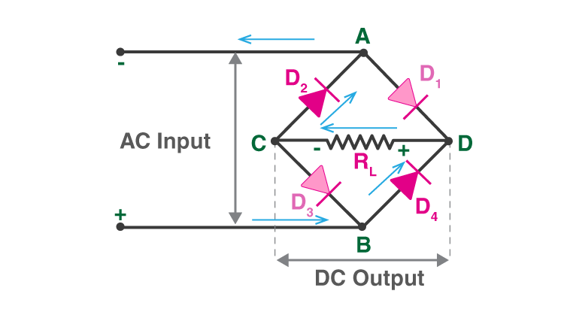

From the figures given above, we notice that the current flow across load resistor RL is the same during the positive half cycle and the negative half cycles. The output DC signal polarity may be either completely positive or negative. In our case, it is completely positive. If the direction of diodes is reversed then we get a complete negative DC voltage.

Thus, a bridge rectifier allows electric current during both positive and negative half cycles of the input AC signal.

The output waveforms of the bridge rectifier are shown in the below figure.

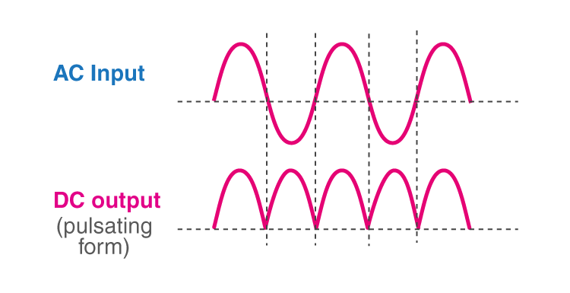

5)Explain the significance of three terminals of bipolar junction transistor, with neat diagram explain common emitter & common base transistor configuration with its current amplification factor and output current equation.(10)

There are three terminals in bipolar junction transistors are explained below.

Emitter − It supplies charge carriers. It is highly doped so that it can inject a large number of charge carriers into the base. Emitter is always greater than base.

Base − Base is middle layer in BJT which is thin compared to emitter and collector. Base is very lighted doped.

Collector − It collects charge carriers. Its doped between emitter and base means moderately doped, but it is always greater than emitter and base in size.

Common emmitor:- The configuration in which the emitter is connected between the collector and base is known as a common emitter configuration. The input circuit is connected between emitter and base, and the output circuit is taken from the collector and emitter. Thus, the emitter is common to both the input and the output circuit, and hence the name is the common emitter configuration.

6) Differentiate between sensor & transducer. 2

Ans:-Sensors are defined as a device which is used to measure a physical quality - for example - light, sound, temperature etc. and give the output in an easy to read format for the user.

Both a sensor and a transducer are used to sense a change within the environment they are surrounded by or an object they are attached to, but, a sensor will give an output in the same format and a transducer will convert the measurement into an electrical signal

A transducer can measure similar qualities to a sensor but will convert the signal from one physical form to another meaning their input and output signals are not the same as each other. Transducers are sometimes referred to as energy converters.

7)What are the main elements of a biosensor? 2

Ans:-These include a biological sensing element, physicochemical detector or transducer and a signal processing system.

Biological sensing elements are used to interact with the analyte of interest to generate a signal.

Sensing elements normally include materials such as tissues, microorganisms, organelles, cell receptors, enzymes, antibodies, and nucleic acids. The signal generated through the interaction of the sensing element and the analyte of interest is then transformed to a measurable and quantifiable electrical signal via the transducer.

The signal processing system therefore amplifies the electrical signal and conveys it to a data processor that produces a measurable signal in the form of a digital display, print out or color change.

8) Mention any two applications of biosensors. 2

Biosensors are used in the food industry to measure carbohydrates, alcohols and acids, for example, during quality control processes. The devices may also be used to check fermentation during the production of beer, yoghurt and soft drinks. Another important application is their use in detecting pathogens in fresh meat, poultry or fish.

9) Classify analog & digital sensors with their functions and applications. 5

Digital sensors are the kind of electrochemical or electrical sensors where the information is converted to digital form and then transmitted. The output of a digital sensor is the distinct digital signal of the quantity which is being measured.

Use of digital sensors:-

Measuring signals are simply converted to digital signal internal to the sensor

Digital sensors have no complication for humidity and corrosion

These can be calibrated separately from the system

ANALOG SIGNALS:-Analog sensors are the devices that produce analog output in correspondence to the quantity being calculated. These sensors also observe the change in external factors such as light intensity, speed of the wind, and solar radiation, and others.

APPLICATIONS OF ANALOG SIGNELS:-Parking sensors

Object alignments

Mobile phones

Industrial fabrications

Automobiles

Robotics

10) Define Transducers. Write its classification and characteristics in detail. 5

11) What is a sensor? What is the criteria to choose a sensor? Explain the different types of sensors with their functions and applications. 10

12) What are biosensors? Describe its main components, working principle and applications in healthcare . 10

13) What are transducers? Mention their different types & their working principle. 10

14) Rectangular iron core with a cut size of 2 cm as shown in given figure, details are as follows – mean length of magnetic circuit= 50 cm, cross section area= 3 cm x 3 cm, Relative permeability= 1000, No of turns in each coil= 200, Current in each coil= 5A. Calculate Flux in air gap.